Order of Service in Church

ALL STAND as the funeral procession enters the church. Once the family are seated, please SIT

The Priest reads one or more scriptural sentences.

The Gathering

Priest: We meet in the name of Jesus Christ, who died and was raised to the glory of God the Father. Grace and mercy be with you.
All: Amen.

The priest introduces the service

Hymn: The day thou gavest, Lord, is ended,
(stand) the darkness falls at thy behest;
to thee our morning hymns ascended,
thy praise shall sanctify our rest.

We thank that thy Church unsleeping,
while earth rolls onward into light,
through all the world her watch is keeping,
and rests not now by day nor night.

As o'er each continent and island
the dawn leads on another day,
the voice of prayer is never silent,
nor dies the strain of praise away.

The sun that bids us rest is waking -
our brethren 'neath the western sky,
and hour by hour fresh lips are making -
thy wondrous doings heard on high.

So be it, Lord; thy throne shall never,
like earth's proud empires, pass away;
thy kingdom stands, and grows for ever,
till all thy creatures own thy sway.

Priest: Sitting or kneeling, let us pray:

As children of a loving heavenly Father, let us ask his forgiveness,
for he is gentle and full of compassion.

All: God of mercy,
we acknowledge that we are all sinners.
We turn from the wrong
that we have thought and said and done,
and are mindful of all that we have failed to do.
For the sake of Jesus, who died for us,
forgive us for all that is past,
and help us to live each day
in the light of Christ our Lord. Amen.

Priest: May God our Father forgive us our sins
and bring us to the eternal joy of his kingdom,
where dust and ashes have no dominion.
All Amen.

Priest: Let us pray

Eternal God, our maker and redeemer,
grant us with Alice and all the faithful departed
the sure benefits of your Son's saving passion
and glorious resurrection:
that, in the last day,
when you gather up all things in Christ,
we may with them enjoy the fullness of your promises;
through Jesus Christ your Son our Lord,
who is alive and reigns with you,
in the unity of the Holy Spirit,
one God, now and for ever.
All: Amen.
The Ministry of the Word

A reading from the First Letter of St Peter

Praise be to the God and Father of our Lord Jesus Christ! In his great mercy he has given us new birth into a living hope through the resurrection of Jesus Christ from the dead, and into an inheritance that can never perish, spoil or fade – kept in heaven for you, who through faith are shielded by God's power until the coming of the salvation that is ready to be revealed in the last time. In this you greatly rejoice, though now for a little while you may have had to suffer grief in all kinds of trials. These have come so that your faith – of greater worth than gold, which perishes even though refined by fire – may be proved genuine and may result in praise, glory and honor when Jesus Christ is revealed. Though you have not seen him, you love him; and even though you do not see him now, you believe in him and are filled with an inexpressible and glorious joy, for you are receiving the goal of your faith, the salvation of your souls.

This is the word of the Lord. Thanks be to God.

Gradual hymn: (please stand)

And did those feet in ancient time
walk upon England's mountains green?
And was the holy Lamb of God
on England's pleasant pastures seen?
And did the countenance divine
shine forth upon our clouded hills?
And was Jerusalem builded here
among those dark satanic mills?

Bring me my bow of burning gold!
Bring me my arrows of desire!
Bring me my spear! O clouds, unfold!
Bring me my chariot of fire!
I will not cease from mental fight,
nor shall my sword sleep in my hand,
till we have built Jerusalem
in England's green and pleasant land.

THE GOSPEL (please remain standing)

Hear the Gospel of our Lord Jesus Christ according to St. John
All: Glory to you, O Lord

Early on the first day of the week, while it was still dark, Mary Magdalene went to the tomb and saw that the stone had been removed from the entrance. So she came running to Simon Peter and the other disciple, the one Jesus loved, and said, "They have taken the Lord out of the tomb, and we don't know where they have put him!"

So Peter and the other disciple started for the tomb. Both were running, but the other disciple outran Peter and reached the tomb first. He bent over and looked in at the strips of linen lying there but did not go in. Then Simon Peter, who was behind him, arrived and went into the tomb. He saw the strips of linen lying there, as well as the burial cloth that had been around Jesus' head. The cloth was folded up by itself, separate from the linen. Finally the other disciple, who had reached the tomb first, also went inside, and he saw and believed.

This is the Gospel of the Lord
All: Praise to you, O Christ

Please be seated
The Address.

The Prayers:

Priest: God of mercy, Lord of life, you have made us in your image to reflect your truth and light: we give you thanks for Alice, for the grace and mercy she received from you, for all that was good in her life, for the memories we treasure today.

(after a short period of silence)

Priest: Lord, in your mercy
All: hear our prayer.

Priest: You promised eternal life to those who believe. Remember for good this your servant Alice, and all who have died and come to mind at this time, including John. Bring all who rest in Christ into the fullness of your kingdom where sins have been forgiven and death is no more.

(after a short period of silence)

Priest: Lord, in your mercy
All: hear our prayer.

Priest: Your mighty power brings joy out of grief and life out of death. Look in mercy on John and all who mourn. Give them patient faith in times of darkness. Strengthen them with the knowledge of your love.

(after a short period of silence)

Priest: Lord, in your mercy
All: hear our prayer.

Priest: Father, you are tender towards your children and your mercy is over all your works. Heal the memories of hurt and failure. Give us the wisdom and grace to use aright the time that is left to us here on earth, to turn to Christ and follow in his steps in the way that leads to everlasting life.

(after a short period of silence)

Priest: Lord, in your mercy
All: hear our prayer.

All: God of mercy, entrusting into your hands all that you have made and rejoicing in our communion with all your faithful people, we make our prayers through Jesus Christ our Saviour. Amen.

THE LITURGY OF THE SACRAMENT

The Peace (Please stand)

Priest: Jesus says: Peace I leave with you; my peace I give to you.
Not as the world gives do I give you.
Do not let your hearts be troubled, neither let them be afraid.

Priest: The peace of the Lord be always with you
All: And also with you

Priest: Let us offer one another a sign of peace.

Everyone is invited to share the peace with one another.

Offertory Hymn:

Love divine, all loves excelling,
joy of heaven, to earth come down,
fix in us thy humble dwelling,
all thy faithful mercies crown.
Jesu, thou art all compassion,
pure unbounded love thou art;
visit us with thy salvation,
enter every trembling heart.

Come, almighty to deliver,
let us all thy grace receive;
suddenly return, and never,
never more thy temples leave.
Thee we would be always blessing,
serve thee as thy hosts above;
pray, and praise thee, without ceasing,
glory in thy perfect love.

Finish then thy new creation:
pure and spotless let us be;
let us see thy great salvation,
perfectly restored in thee;
changed from glory into glory,
till in heaven we take our place,
till we cast our crowns before thee,
lost in wonder, love and praise.
Please kneel

Priest: May all who are called to a place at your table
follow in the way that leads to the unending feast of life. Amen

Eucharistic Prayer A

Priest: The Lord is here.
All: His Spirit is with us.

Priest: Lift up your hearts.
All: We lift them to the Lord.

Priest: Let us give thanks to the Lord our God.
All: It is right to give thanks and praise.

Priest: It is indeed right, it is our duty and our joy, at all times and in all places to give you thanks and praise, holy Father, heavenly King, almighty and eternal God, through Jesus Christ your Son our Lord.

And now we give you thanks because through him you have given us the hope of a glorious resurrection; so that, although death comes to us all, yet we rejoice in the promise of eternal life; for to your faithful people life is changed, not taken away; and when our mortal flesh is laid aside an everlasting dwelling place is made ready for us in heaven.

Therefore with angels and archangels, and with all the company of heaven, we proclaim your great and glorious name, for ever praising you and saying:
All: Holy, holy, holy Lord, God of power and might, heaven and earth are full of your glory. Hosanna in the highest. Blessed is he who comes in the name of the Lord. Hosanna in the highest.

Priest: Accept our praises, heavenly Father, through your Son our Saviour Jesus Christ, and as we follow his example and obey his command, grant that by the power of your Holy Spirit these gifts of bread and wine may be to us his body and his blood;

who, in the same night that he was betrayed, took bread and gave you thanks; he broke it and gave it to his disciples, saying: Take, eat; this is my body which is given for you; do this in remembrance of me.

In the same way, after supper he took the cup and gave you thanks; he gave it to them, saying: Drink this, all of you; this is my blood of the new covenant, which is shed for you and for many for the forgiveness of sins. Do this, as often as you drink it, in remembrance of me.

Therefore, heavenly Father, we remember his offering of himself made once for all upon the cross; we proclaim his mighty resurrection and glorious ascension; we look for the coming of your kingdom, and with this bread and this cup we make the memorial of Christ your Son our Lord.

Priest: Great is the mystery of faith:
All: Christ has died: Christ is risen: Christ will come again.

Priest Accept through him, our great high priest, this our sacrifice of thanks and praise, and as we eat and drink these holy gifts in the presence of your divine majesty, renew us by your Spirit, inspire us with your love and unite us in the body of your Son, Jesus Christ our Lord.

Through him, and with him, and in him, in the unity of the Holy Spirit, with all who stand before you in earth and heaven, we worship you, Father almighty, in songs of everlasting praise:
All: Blessing and honour and glory and power
be yours for ever and ever. Amen.

Priest: Let us pray with confidence as our Saviour taught us
All: Our Father, who art in heaven, hallowed be thy name; thy kingdom come; thy will be done; on earth as it is in heaven. Give us this day our daily bread. And forgive us our trespasses, as we forgive those who trespass against us. And lead us not into temptation; but deliver us from evil. For thine is the kingdom, the power and the glory, for ever and ever. Amen.

Priest: We break this bread to share in the Body of Christ.
All: Though we are many, we are one body,
because we all share in one bread.

Priest: Jesus is the Lamb of God who takes away the sin of the world.
Blessed are those who are called to his supper.
All: Lord, I am not worthy to receive you,
but only say the word, and I shall be healed.

Holy Communion is administered at the front of Church. Everyone is warmly invited to receive Holy Communion at this Eucharist. Those who prefer to receive a blessing are also invited to come forward at the same time.

After Communion:

All: Heavenly Father,
in your Son Jesus Christ
you have given us a true faith and a sure hope.
Strengthen this faith and hope in us all our days,
that we may live as those who believe in
the communion of saints,
the forgiveness of sins
and the resurrection to eternal life;
through Jesus Christ our Lord. Amen.

Hymn: Thine be the glory, risen, conquering Son,
(stand) endless is the victory thou o'er death has won;
angels in bright raiment rolled the stone away,
kept the folded grave-clothes where thy body lay.
Thine be the glory, risen, conquering Son,
endless is the victory thou o'er death hast won.

Lo, Jesus meets us, risen from the tomb;
lovingly he greets us, scatters fear and gloom;
let the Church with gladness hymns of triumph sing,
for her Lord now liveth, death hath lost its sting:

No more we doubt thee, glorious Prince of Life;
life is naught without thee: aid us in our strife;
make us more than conquerors through thy deathless love;
bring us safe through Jordan to thy home above.

Commendation and farewell [please remain standing]

Priest: Let us commend Alice to the mercy of God our Maker and Redeemer.

The coffin is sprinkled with water taken from the baptismal font

Priest: With this water we call to mind Alice’s baptism. As Christ went through the deep waters of death for us, so may he bring us to the fullness of resurrection life with Alice and all the redeemed.

God our creator and redeemer, by your power Christ conquered death and entered into glory. Confident of his victory and claiming his promises, we entrust Alice to your mercy in the name of Jesus our Lord, who died and is alive and reigns with you, now and for ever. Amen

May God, in his infinite love and mercy, bring the whole Church, living and departed in the Lord Jesus, to a joyful resurrection, and the fulfilment of his eternal kingdom. Amen.

As the procession leaves church, the Nunc Dimittis may be read. Please follow the family.

Acknowledgement: Common Worship: Pastoral Services, material from which is included in this service, is copyright © The Archbishops’ Council (2000)

The Parish Church of St Barnabas

Warrington

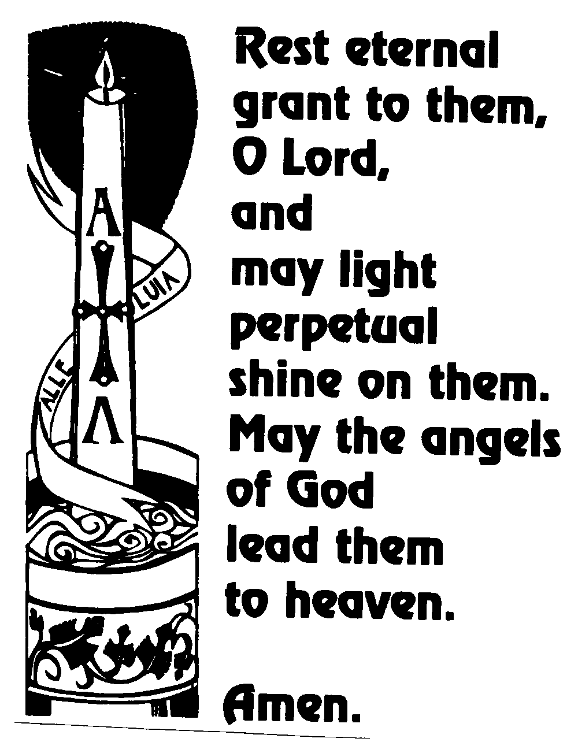

ALICE McCUE

2 January 1920 – 16 October 2002

I am sure that neither life nor death, nor angels, nor principalities nor powers, nor things present, nor things to come, nor height, nor depth, nor anything else in all creation can separate us from the love of God in Christ Jesus our Lord.

